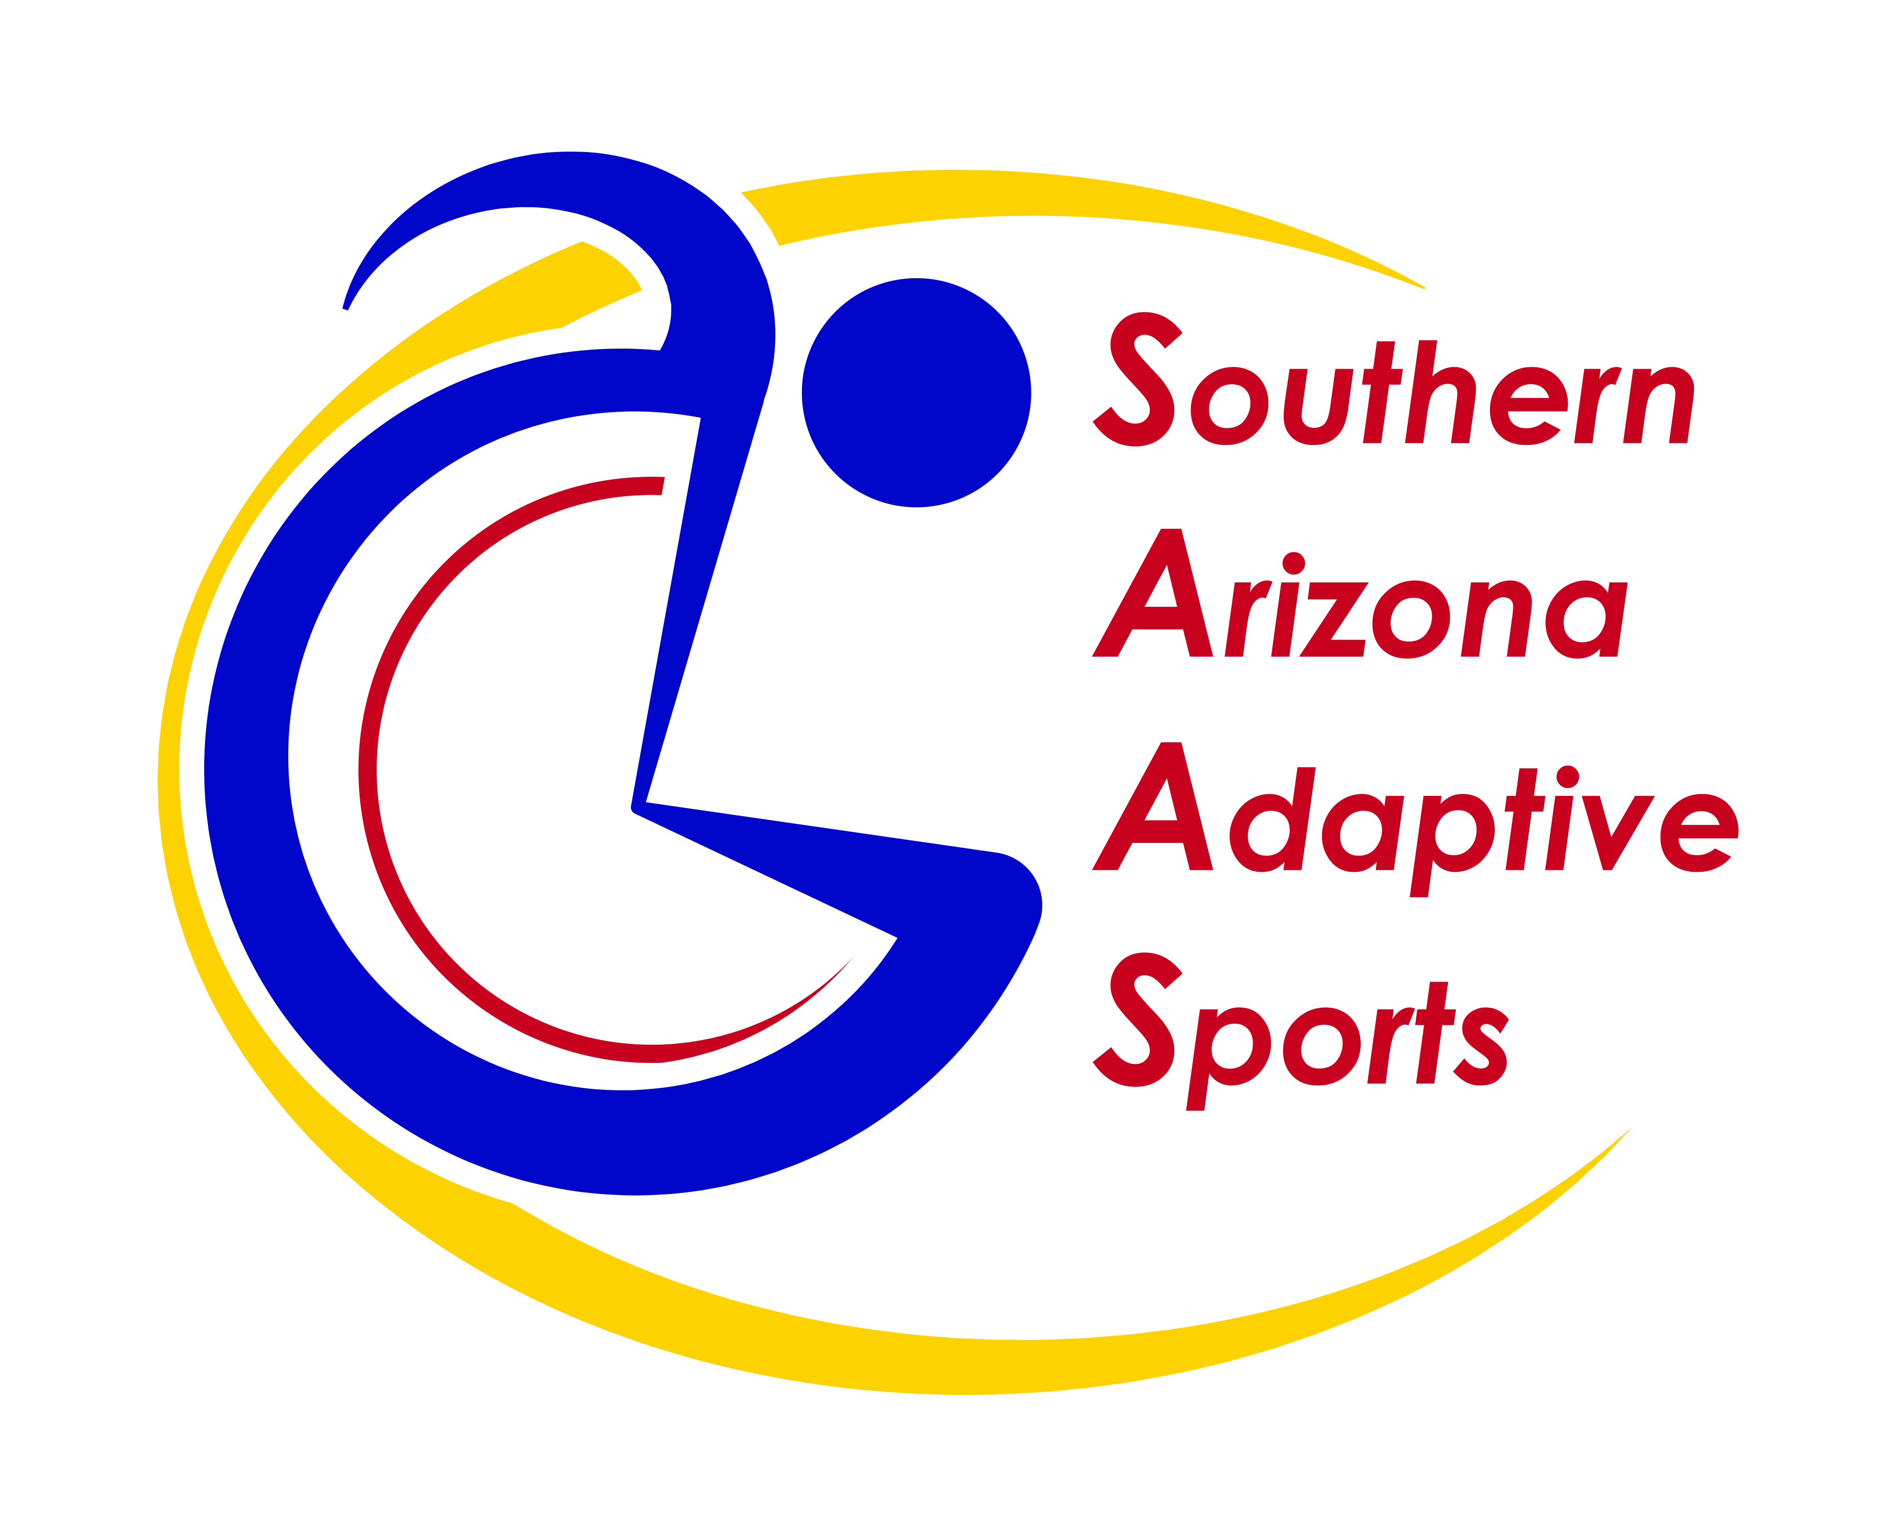

Southern Arizona Adaptive Sports (SAAS) announces

The Eduardo Aguirre Adaptive Cycling & Outdoor Adventure Center

Eduardo Aguirre (1959-2023) was an avid hand cyclist who loved people, handcycling, and the outdoors. Eduardo spent the winters in Tucson, Arizona where he rode his handcycle thousands of miles annually, breaking barriers, making friends, and building bridges with his effervescent personality. Eduardo managed SAAS’s adaptive cycling program and social media. He worked tirelessly to grow participation in adaptive cycling. He grew the Ascension Cycling Team expanding to 50 adaptive cyclists in El Tour de Tucson 2022 thanks to support from AGM Container Controls/Ascension Wheelchair Lifts.
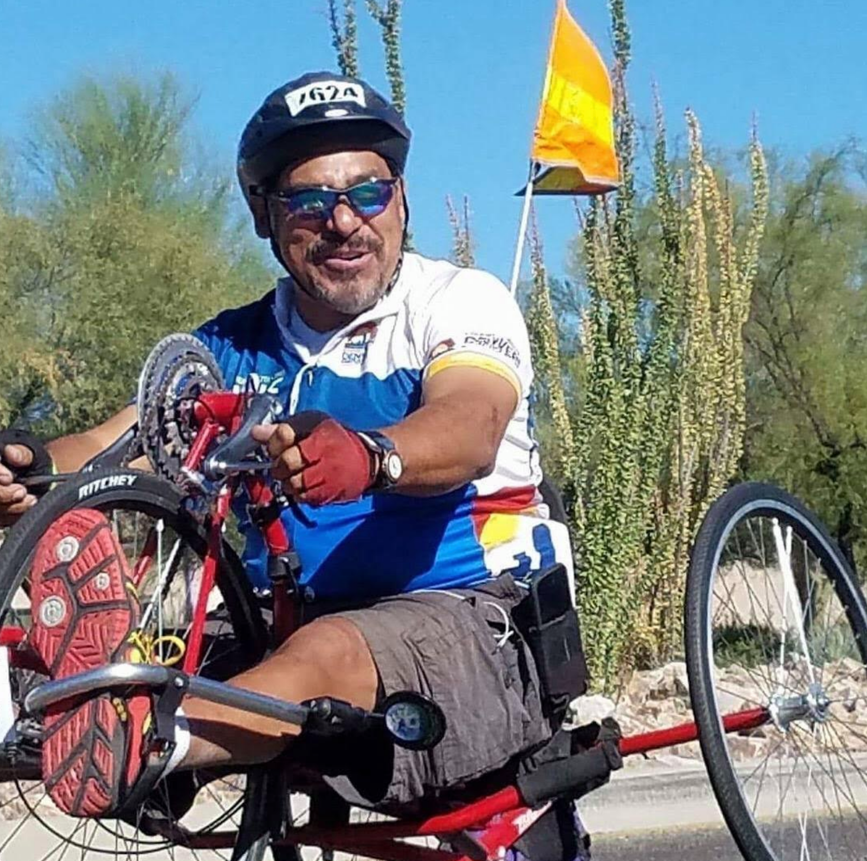
Eduardo died from suicide on March 15th after a long struggle with depression. In Eduardo’s memory and in support of good mental and physical health, SAAS is creating an Adaptive Cycling & Outdoor Adventure Center on the bank of the Rillito River along The Loop. A satellite center will be maintained in Sam Lena Park, home of the SAAS VeloVets adaptive cycling program for Veterans. The Centers will be built from recycled shipping containers and will integrate accessibility, universal design, and shaded gathering areas. They will be central staging points for adaptive cycling, wheelchair fitness, hiking, birding, and outdoor adventures.

With over 50 adaptive cycles, SAAS has one of the largest adaptive bike fleets in Southern Arizona.
Our options include:
- Handcycles for individuals with limited or no leg movement
- Recumbent trikes for those who need more stability
- Hand and foot-powered cycles & trikes for children
- Tandem cycles for individuals who want a guide or stoker while riding
- Standard 2-wheeled bicycles
- Off-road wheelchairs and mobility devices
The Eduardo Aguirre Adaptive Cycling & Outdoor Adventure Center’s locations will provide easy access to The Chuck Huckleberry Loop, Tucson’s 137-mile system of paved, shared-use paths connecting the waterways and greenways of Pima County. Cyclists and wheelchair users will have direct access to protected, vehicle-free paths. Hikers and birders can explore the trails along the Rillito River and Sam Lena Recreation Area in wheelchairs and mobility devices. Everyone can pursue fitness, recreation, and good physical and mental health in Tucson’s beautiful outdoor environment.
The Centers will be open in the Fall and winter Season (October – May) for on-site ‘rentals’ free of charge (donations gratefully accepted). Online and phone appointment systems will allow people to reserve their favorite cycle for 2-hour use. Adaptive cycle rentals for off-site use will be available for a nominal suggested donation.
Partners & funders are welcome to join us in this unique project. By registering to ride in El Tour de Tucson and selecting Southern Arizona Adaptive Sports, you can start a fundraising page to help build support and awareness of this project. Contact Mia for financial assistance through our generous sponsor – OMEO AMERICA
Current Partners include:
- Pima County / Kino Sports Complex
- University of Arizona Adaptive Athletics
- AARP Community Challenge Grant
- Alan Harris Foundation
- Craig H. Neilsen Foundation
- AGM Container Controls / Ascension Wheelchair Lifts / Omeo
- Southern Arizona VA Healthcare

For more information on how to support this project, please contact:
Mia Hansen, Founder/Executive Director
Southern Arizona Adaptive Sports 520-370-0588 miajhansen08@gmail.com

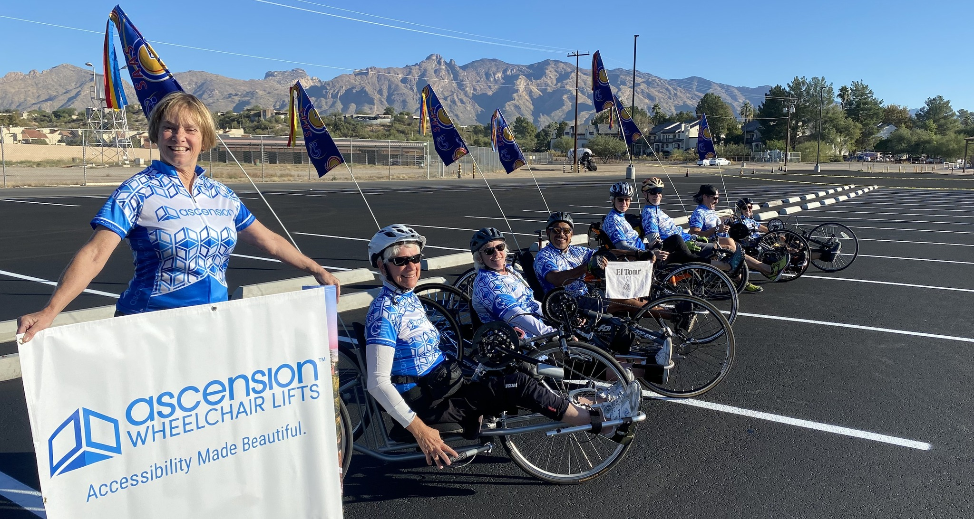
GROUP ADAPTIVE CYCLING RIDES – Sam Lena Park 3400 S. Country Club starting in October 2023:
Tuesdays 4:00pm with VeloVets (Veterans & Family member)
Thursdays & Saturdays 7:00am with OMEO Cycling Team
Sundays by appointment with SAAS – Cal Mia 520-370-0588

